MZUZU DIOCESE SECONDARY SCHOOLS
2016 MALAWI SCHOOL CERTIFICATE MOCK EXAMINATION
MATHEMATICS
PAPER I (100 Marks)
Subject Number: M131/1
Time Allowed: 2 Hours
7.30 – 9.30 am
Question  Number | Tick if  answered | Do not write in this column
1
2
3
4
5
6
7
8
9
10
11
12
13
14
15
16
17
18
19
20
Total
Thursday, March 17

Instructions
1. This paper contains 12 pages. Please check.
2. Answer all the 20 questions in this paper.
3. Write your answers in the spaces provided for each question.
4. Show all your working clearly.
5. Electronic calculators may be used.
6. Make sure you have written your Examination Name on all pages of the question paper in the spaces provided.
7. In the table provided on this page, tick against the question number you have answered.
8. Hand in your examination paper to the invigilator when time is called to stop writing.

© 2016 DIOCESE Turn over

- If $f\left(x\right)=x-42$ find the domain whose range is $\left(-3,0\right)$ (5 marks)

- Factorise the following expression $6x^{2}-11xy-10y^{2}$ (4 marks)

- Simplify$\sqrt[ 4]{16t}$ + 3 $\sqrt[4]{t}$ -$\sqrt[4]{81t}$ (4 marks)

- Figure 1 below shows a triangle ABC inscribed in a circle centre O. AB is parallel to CE and AOCD is a straight line. Angle DCE = 36⁰
B
E
D
A
A
A
A
A

C
O

Find the angle BCA? (4 marks)

- If $y{(yf-p)}^{-1}=11$, express $y$ in terms of $f and p.$ (5 marks)

- Solve for $x$ in $\log_{10}{(3x-5)}=2\log_{10}{5}-1$ (6 marks)

- Given that $2x, x, x+3$ are the first three terms of a geometric progression ,calculate the value of $x$ (5 marks)

- Find the value of $A$ and $B$ if $x^{2}-4x+A≡{\left(x-B\right)}^{2}+4$ (5 marks)

- James has 6 red sweets and 4 green sweets in his pocket. He eats two sweets of different colours. What is the probability that the third sweet will be red? (3 marks)

- A cone of radius 4cm and height 7cm is used to fill a cylinder of radius 4cm and height 7cm with sand. How many cones will be needed to fill the cylinder? (5 marks)

- The sides of two square fields are in the ratio 4:5. The area of the larger field is 1296 cm² greater than the area of the smaller field. Find the area of the larger field. (6 marks)

- Find the equation of a line parallel to $y-4x=5$ which passes through(3,2) (6 marks)

- From the top of a tower 30 metres high, the angles of depression of two boats, A and B, are 30⁰ and 60⁰ respectively. Given that the two boats are in a straight line with the tower, calculate the distance between the two boats to the nearest metre. (7 marks)

- Find the value of $x$ and $y$in the following matrix equation

$\left[\begin{matrix}3 & 7 \\ 2 & -1\end{matrix}\right]\left[\begin{matrix}x \\ y\end{matrix}\right]$ = $\left[\begin{matrix}11 \\ -4\end{matrix}\right]$ (5 marks)

- Given that $A and B$are subsets of$U$;
$$U= \left\{1,2,3,4,5,a,b,c,d,e\right\}$$
$$A= \left\{1,3,a,b\right\}$$
$$B= \left\{2,4,5,c,d\right\}$$
Find ${( B^{'})}^{'}∩A^{'}$ (3 marks)

- Determine whether the following points are collinear or not
$A\left(0,2\right), B\left(2,5\right), and C(3,7)$ (5 marks)

- Given that s varies directly as m and inversely as the square of t, and that $s=m$ when $t=3$, calculate the value of s when $t=2$ and $m=5$. (6 marks)

- Figure 2 is a graph showing the movement of an object in 45 seconds.
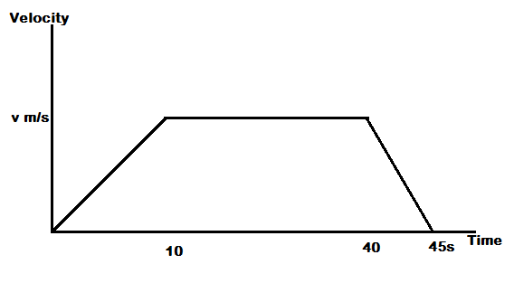

Given that the object travelled a total distance of 170 metres, calculate the maximum speed attained by the object. (5 marks)

- A region is defined by the inequalities $x≥0$ ,$y≥0$, $3x+2y≤12$, $7x+3y≤21$. Sketch the graphs to show the region described by these inequalities by shading the unwanted region (5 marks)

- Figure 3 shows a graph of the equation $y=ax^{2}+bx+c$
-2
1
-4

Find the equation of the parabola (6 marks)

END OF QUESTION PAPER

